Setting Up Application Environment

Create IBM Cloud Account

|  |  |
| --- | --- |
| Date | 31-10-2022 |
| Team ID | PNT2022TMID31805 |
| Project Name | Personal Expense Tracker Application |

**Step 1:**

Type or click the below link in the browser <https://www.ibm.com/academic/home>

**Step 2:**

Click register icon and give all the details one by one.

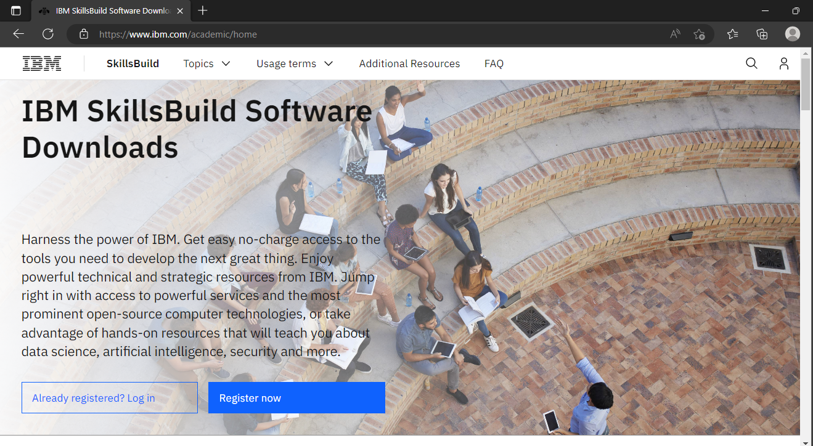

**Step 3:**

Already you got SI EMAIL and SI PASSWORD from your IBM student login. Login to your web mail account. Wait for 7-digit verification code in your web mail: <https://sg2plmcpnl496936.prod.sin2.secureserver.net:2096/>

**Step 4:**

Get 7-digit verification code in webmail, then go to registration page and enter the verification code.

**Step 5:**

Now, you have successfully created the IBM Cloud Account.

**Step 6:**

Go to IBM Cloud login page: https://cloud.ibm.com/login ,then enter your IBM Id and Password.

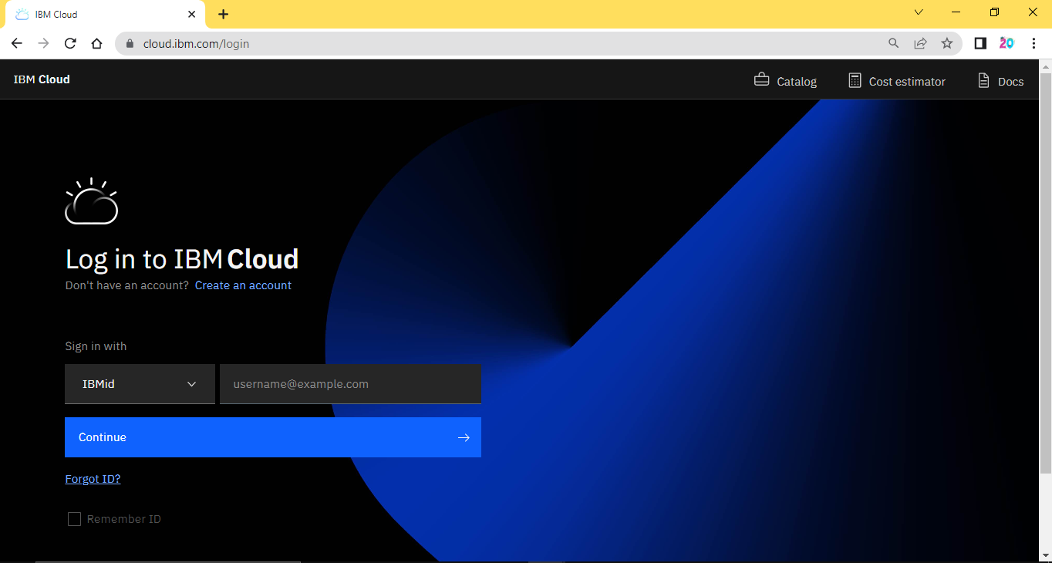

**Step 7:**

Finally, you will access the IBM cloud account

